**LIBRARY MANAGEMENT SOFTWARE**

**A PROJECT REPORT**

***Submitted by :***

**NISHA SHISHODIA**

***in partial fulfillment of the requirement of***

CBSE AISSCE 2018-19

IN

INFORMATICS PRACTICES

**CAMBRIDGE SCHOOL GREATER NOIDA**

CLASS XII

CBSE ROLL NUMBER -

SESSION 2018 – 2019

**CAMBRIDGE SCHOOL GREATER NOIDA**

**BONAFIDE**

**CERTIFICATE**

This is to certify that “**Nisha Shishodia”** of class XII has successfully completed the project entitled “**Library Management Software**” under the supervision of Mrs. Sheetal Yadav in the academic session 2018 – 2019 towards the partial fulfillment of AISSCE Informatics Practices Practical examination conducted by CBSE.

Mrs. Sheetal Yadav

(PGT – Informatics Practices)

External Examiner

**Index**

|  |  |
| --- | --- |
| **Content** | **Page No.** |
| Preface | 3 |
| System Specification | 4 |
| Hardware Specification |
| Software Specification |
| Design | 6 |
| Table Structure | 7 |
| Form Specifications | 10 |
| Output | 11 |
| Coding | 23 |
| Limitations | 52 |
| References |  |
|  |  |
|  |  |

**PREFACE**

This program has been prepared with the very sole purpose of managing and maintaining the records of books issued by various people in the libraries . The program is handy and very easy to use . It is user – interface friendly.Data of varois books can be added and altered simultaneously with ease.Records of new members can also be added and manipulated without any hindrance.It helps to maintain a segregated and organised data. User can also generate bill of payment to be made just by the help of issued invoice number.Various components of java have been used in the program to give it a pleasing look . The Components used are as follows:

* JFrames
* Jtextfields
* JLabels
* JRadioButtons
* JCheckbuttons
* JComboboxes
* JList
* JButtons
* JPanels
* JPasswordfields
* JButtonGroups
* JMenubar
* JMenuItems
* JMenu

**System Specifications**

**Hardware Specifications**

* Processor : Intel CORE i3
* Ram : 2GB
* Harddisk : 250 GB
* Network Card : Ethernet / WiFi

**Software Specifications**

* Operating System : Edubuntu 14.04 ITS
* Client Side Validation : Java Netbeans IDE 8.1
* Server Side Validation : MySQL 5.5.47 Server
* Connector : JDBC
* Libre Office
* GIMP

***DESIGN***

1. **Table Structure**

**Login Table**

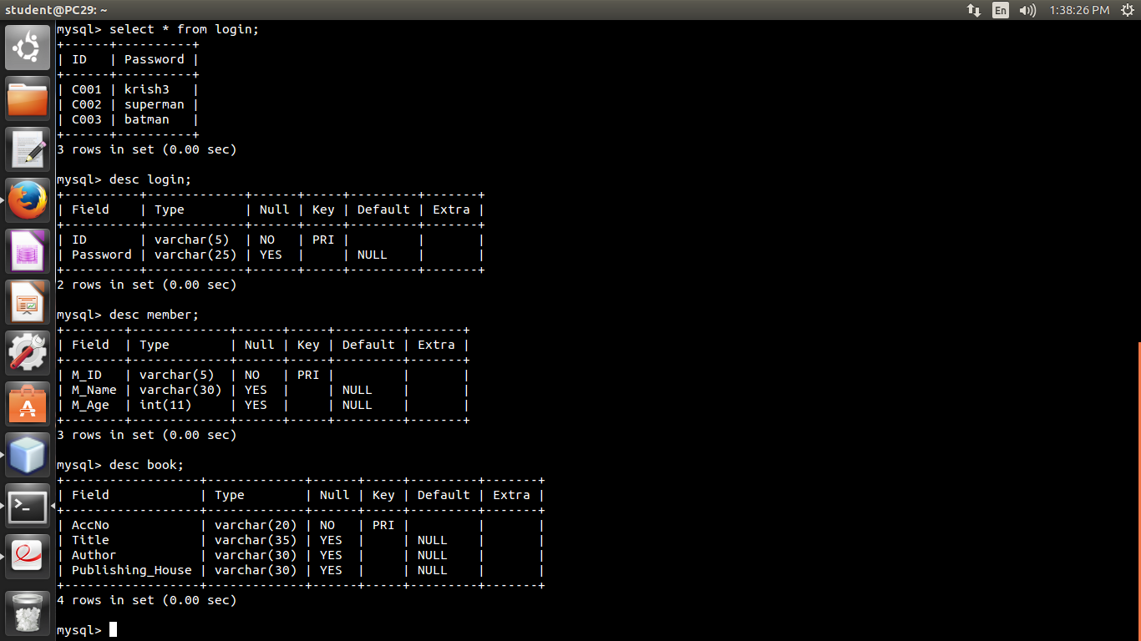

ID varchar(5) Primary Key : Stores the user id of defined users

Password varchar(25) : Stores password of the respective user id

**Member Table**



M_ID varchar(5) Primary Key : Stores the member id of the member of library

M_Name varchar(30) : Stores the name of the member of library

M_Age integer : Stores the age of the member of library

**Book Table**



AccNo varchar(20) Primary Key : Stores the accession number of the book

Title varchar(35) : Stores the title of the book

Author varchar(30) : Stores author’s name of the book

Publishing_House varchar(30) : Stores name of the publishing house of the book

**Issue_Book Table**

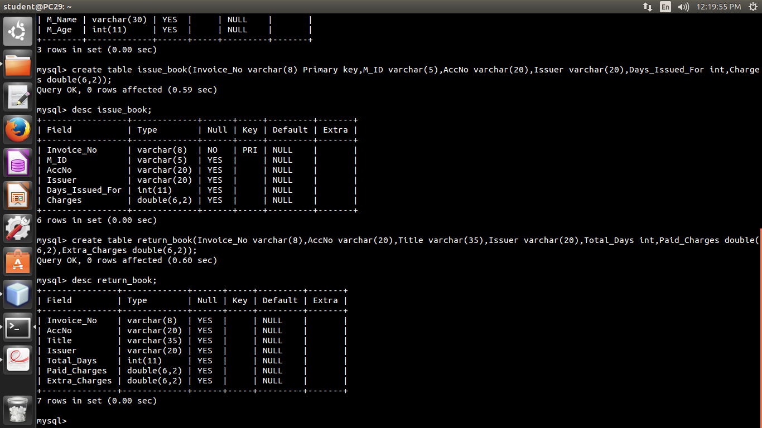

Invoice_No varchar(8) Primary Key : Stores the invoice number of the bill

M_ID varchar(5) : Stores the member id if the issuer is a member of library

AccNo varchar(20) : Stores the accession number of the book issued

Issuer varchar(20) : Stores the name of the issuer

Days_Issued_For integer : Stores the number of days the book is issued for

Charges double(6,2) : Stores the net calculated charges to be paid by the issuer

**Return_Book Table**



Invoice_No varchar(8) Primary Key : Stores the invoice number of the bill

AccNo varchar(20) : Stores the accession number of the book returned

Issuer varchar(20) : Stores the name of the issuer

Total_Days integer : Stores the number of days after which the book is returned

Paid_Charges double(6,2) : Stores total charges paid including fine

Extra_Charges double(6,2) : Stores the fine for late return

**b) Form Specifications**

1. Login form : it is the first page used for signing – in in the program
2. Homepage : it is the main page of the program, used for access to different forms including forms for inserting book records , member sign-ups and generating bill.
3. Insert book records : it is used to insert records of books
4. Manipulation of book records : it is used to search , update and delete individual records
5. Retrieve book records : it is used to retrieve records dependeing upon any condition
6. Member Sign up : it is used to store information about new members of library
7. Manipulation of member records : it is used to search , update and delete individual member records
8. Retrieve member records : it is used to retrieve records depending upon any condition
9. Issue book : it is used to issue a single book to a reader and an invoice for a limited time period
10. Return book : it is used to calculate the total charges to be paid by the issuer alongwith any extra charges if applicable
11. Generate bill : it is used to generate a bill slip for a user who has issued any book

***OUTPUT***

**Form 1 : Login Page**

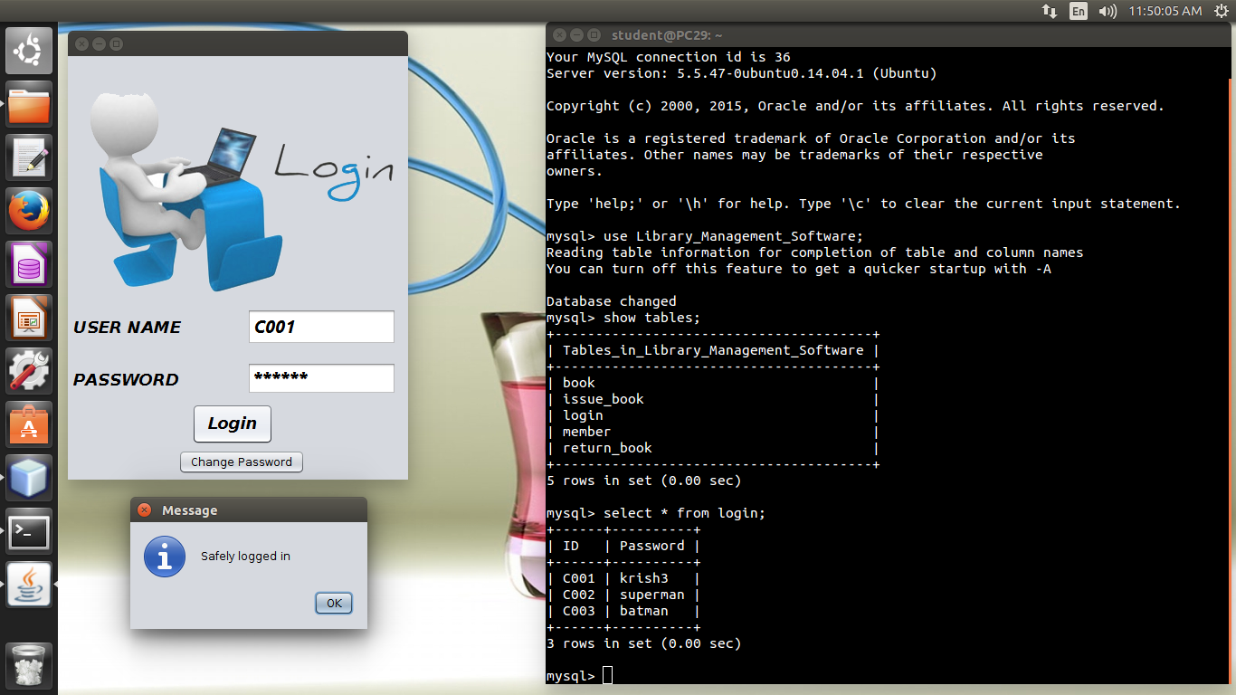

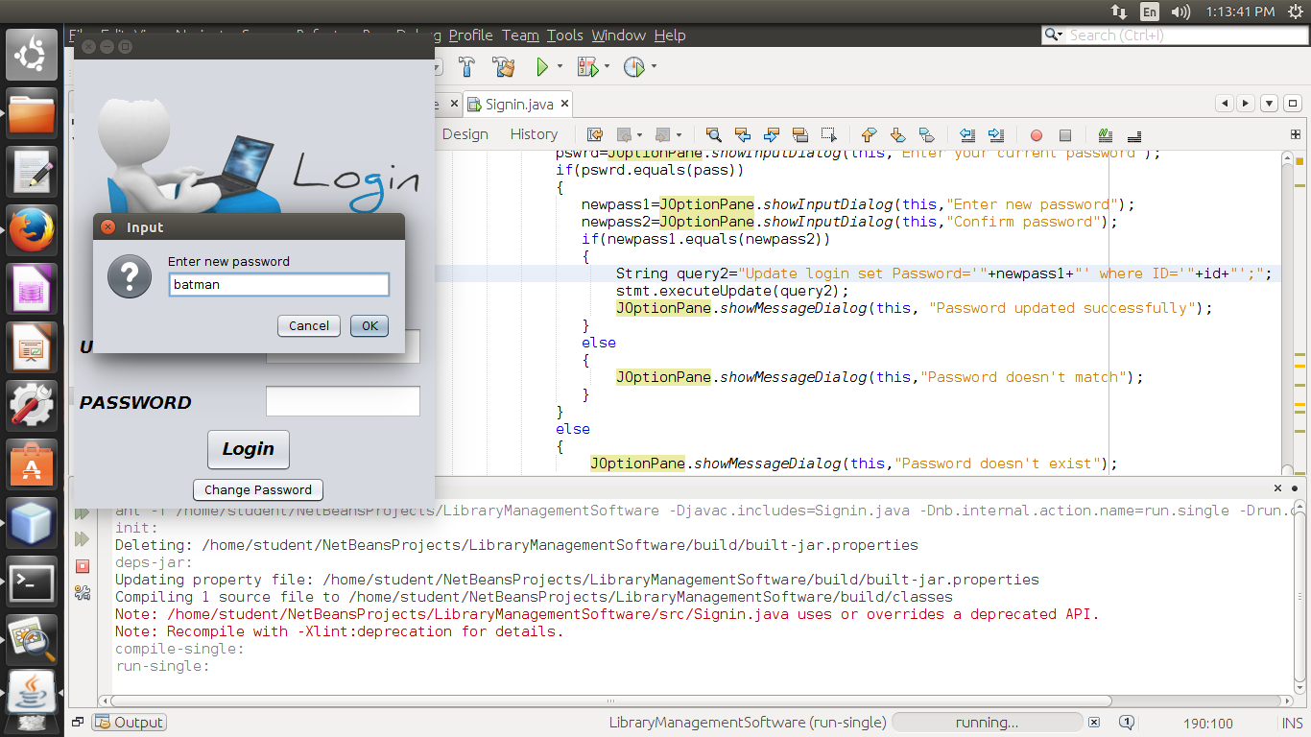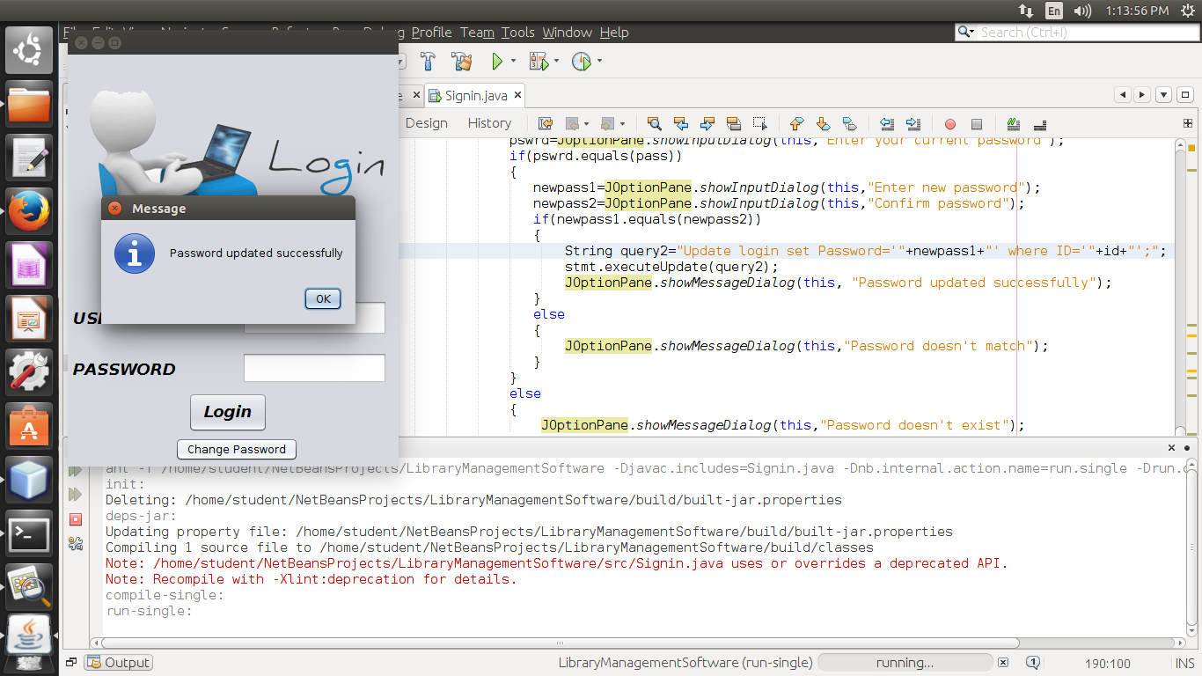

**Form 2 : Homepage**

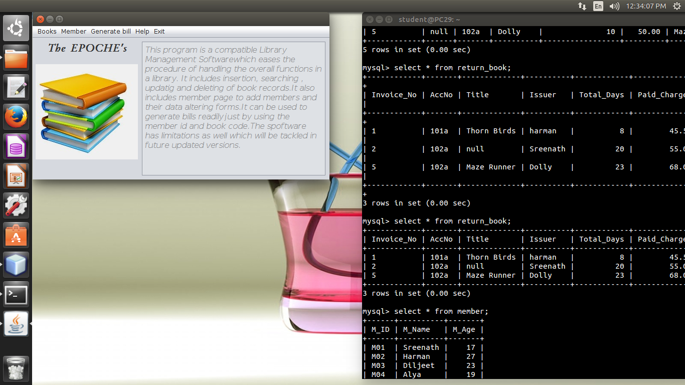

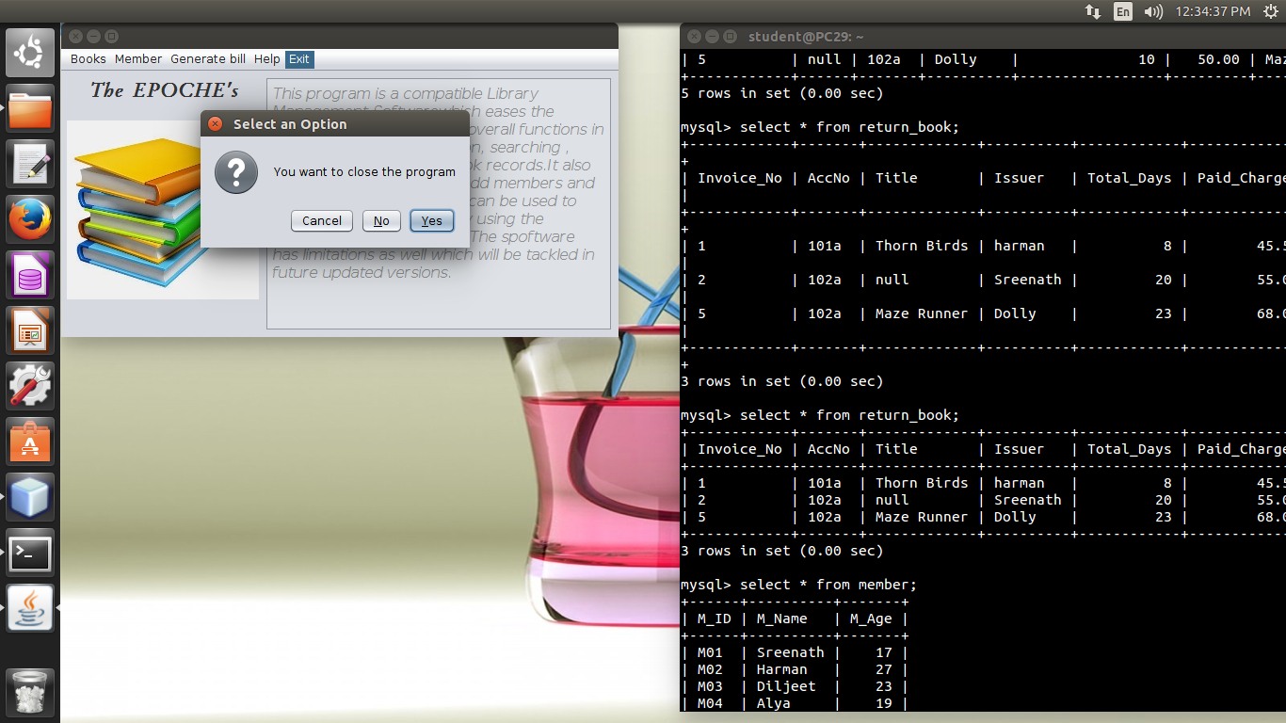

**Form 3 : Insert Book Records**

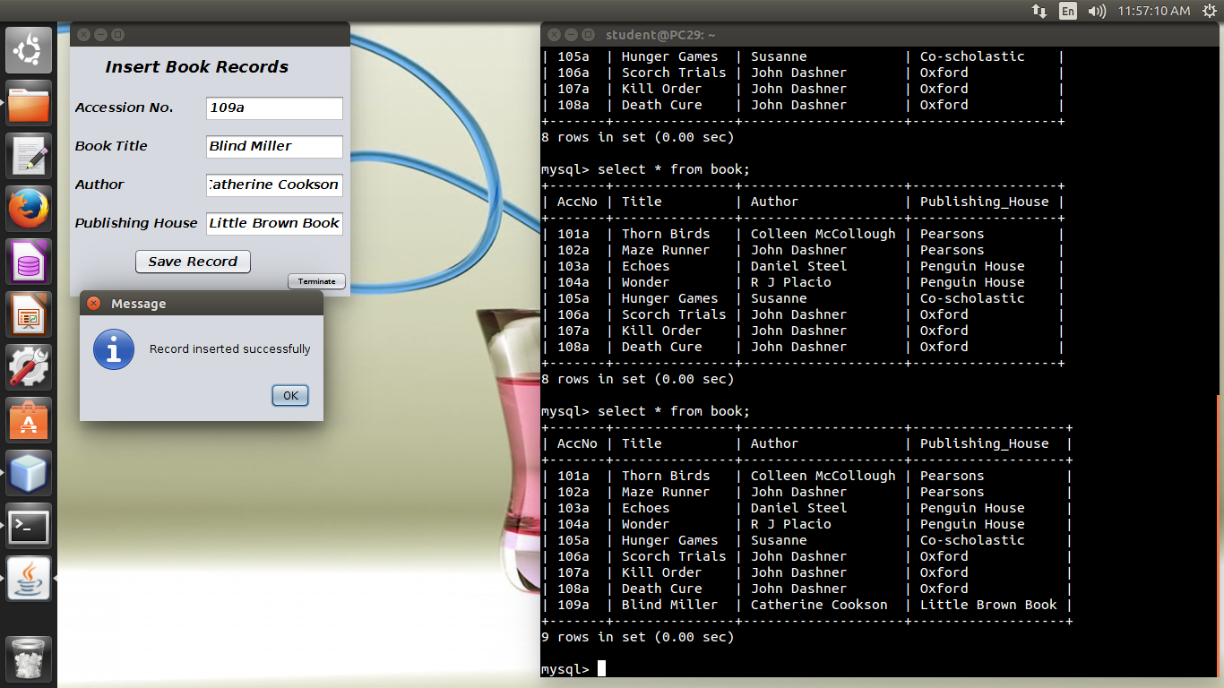



**Form 4 : Manipulation of Book Records**

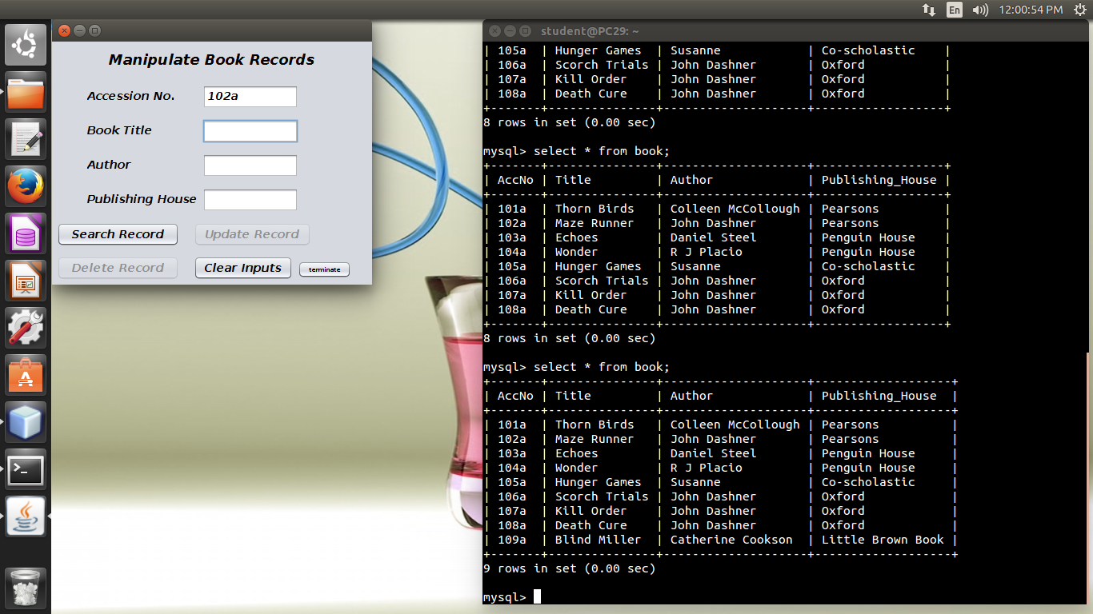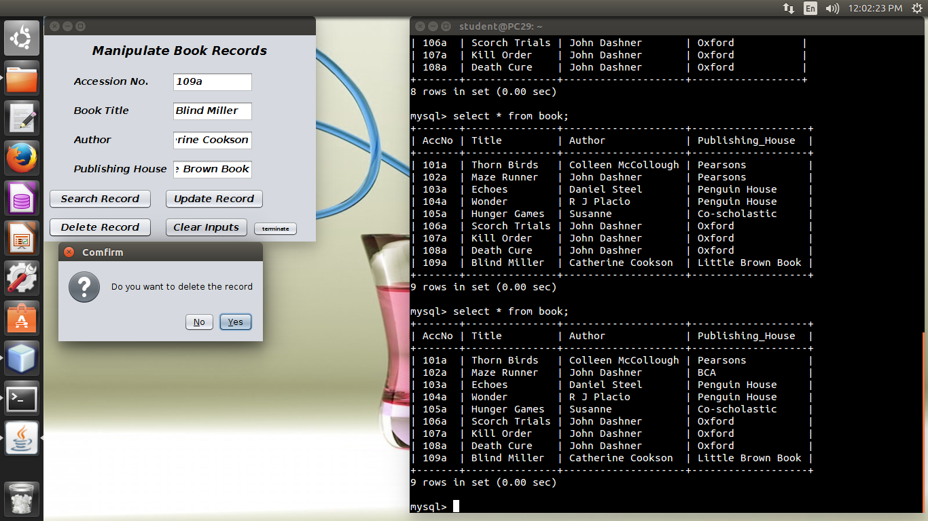

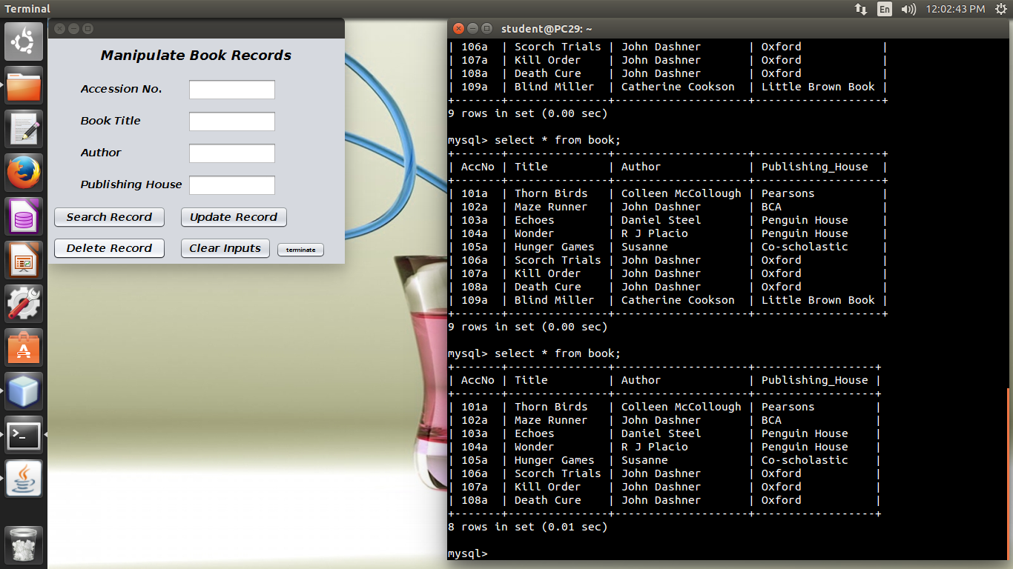

**Form 5 : Retrieve records depending on criteria**

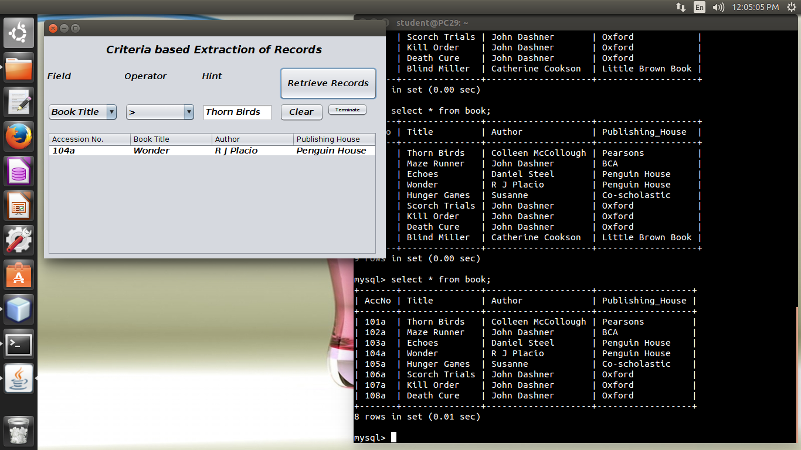

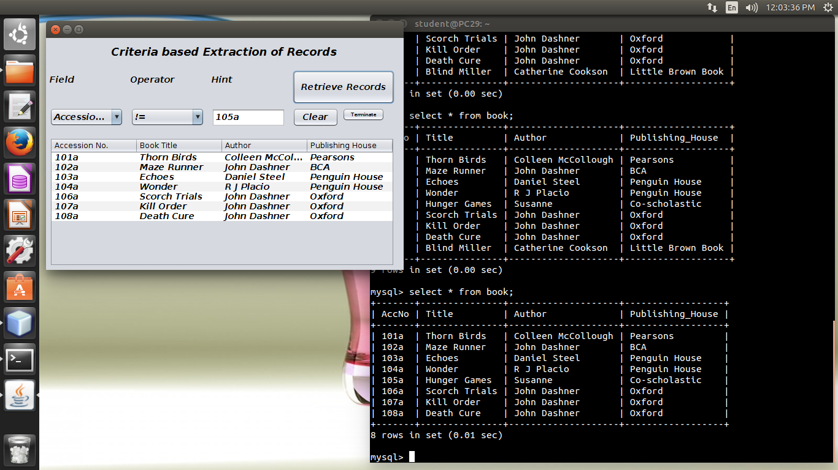

**Form 6 : Member Sign up**

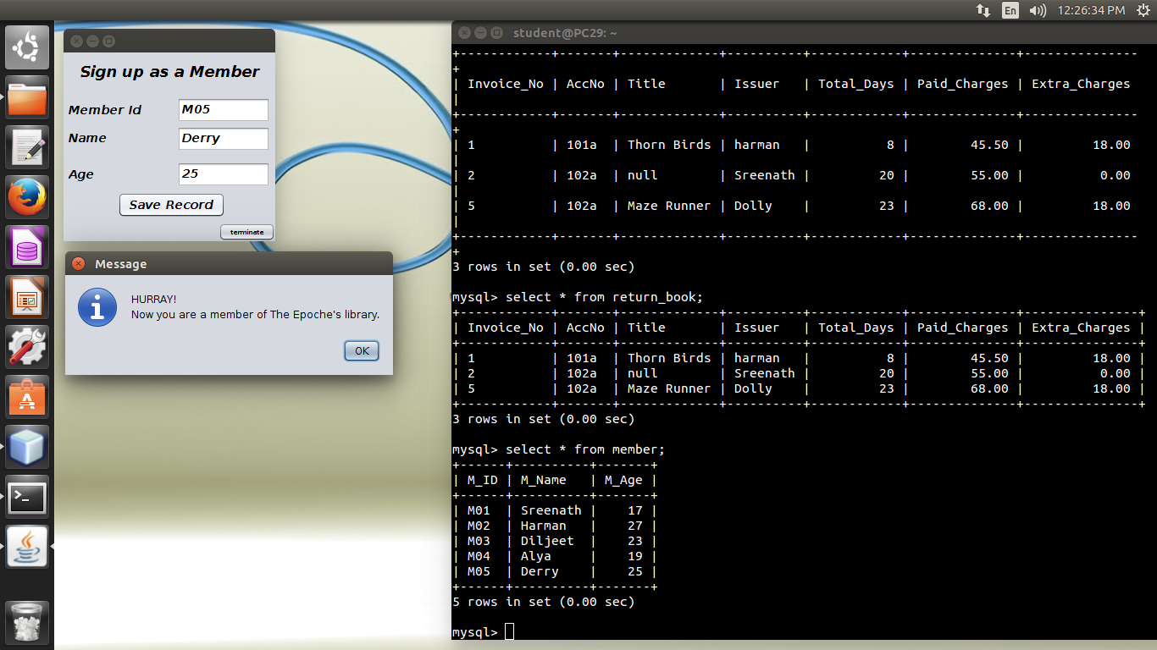



**Form 7 : Manipulation of Member Records**

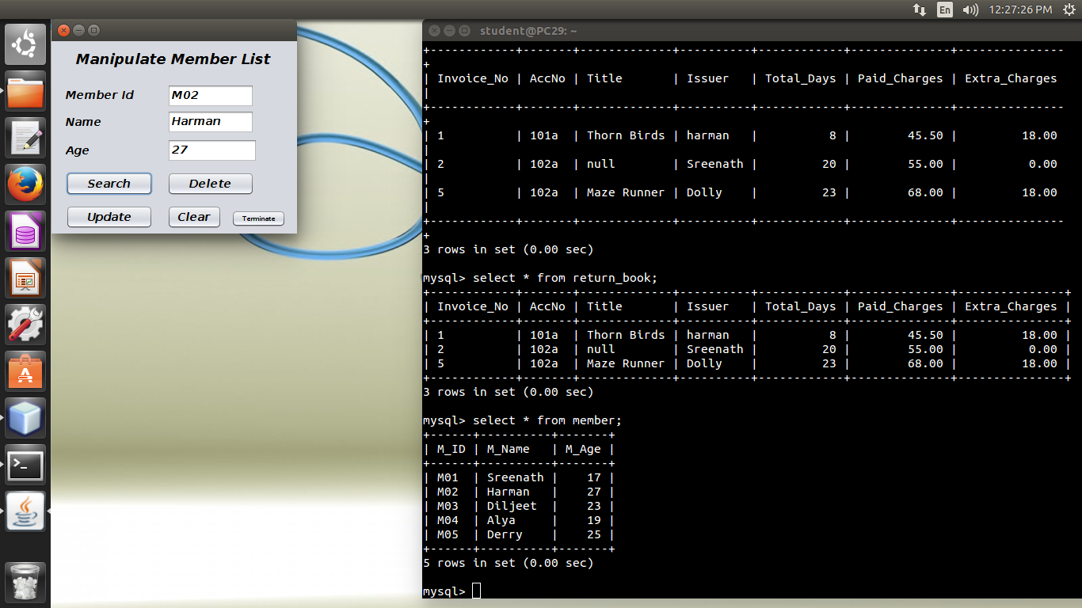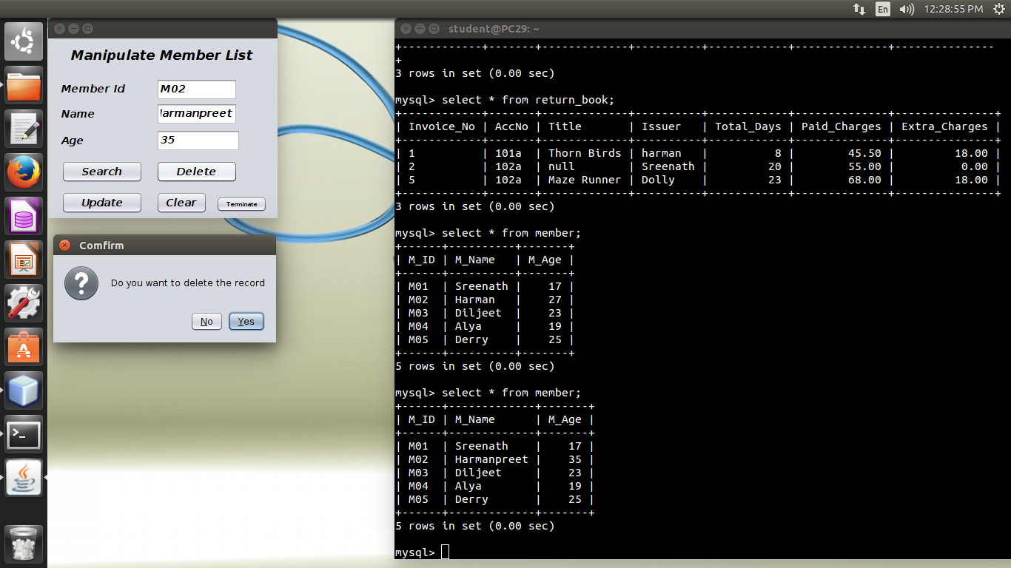

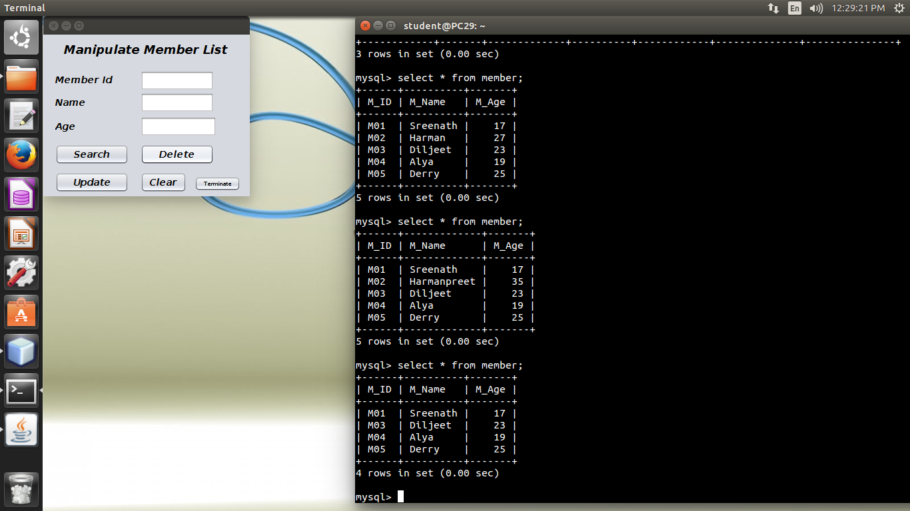

**Form 8 : Retrieve records depending on criteria**

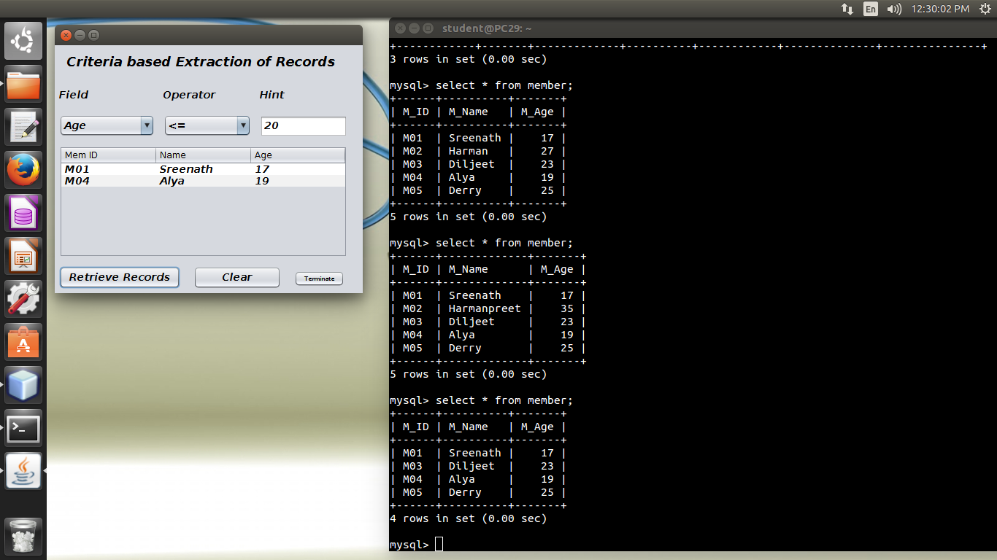

**Form 9 : Issue Book**

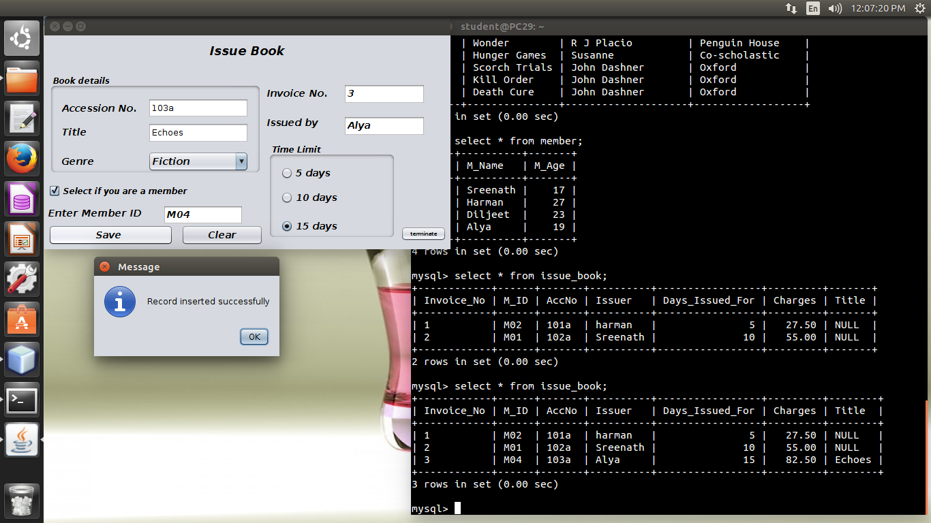

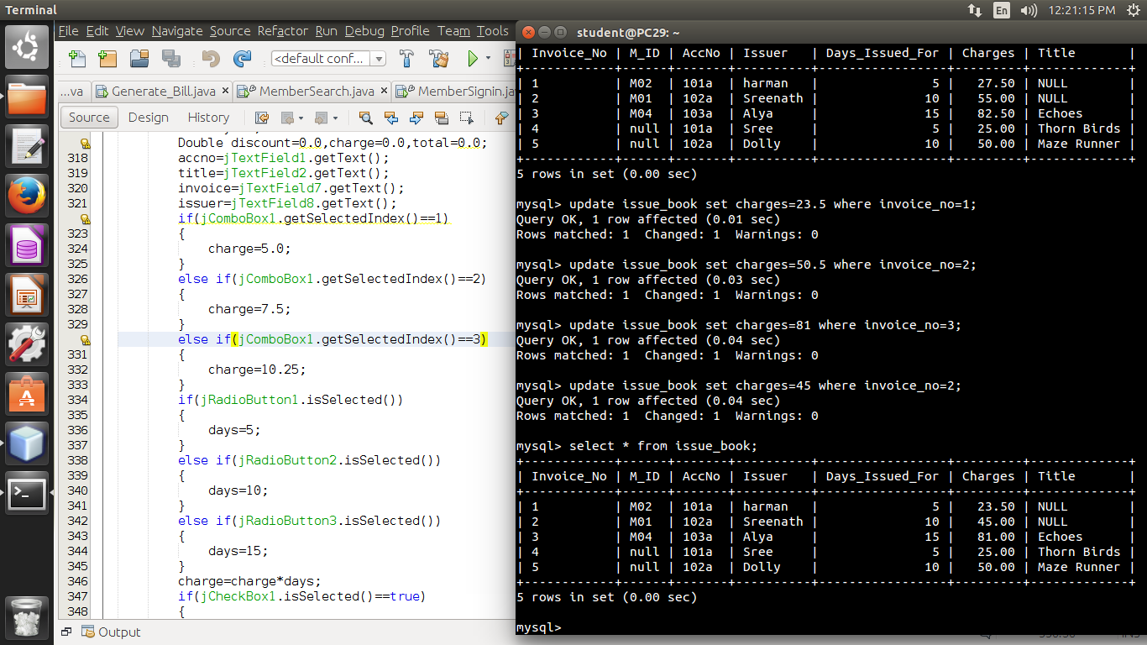

**Form 10 : Return Book**

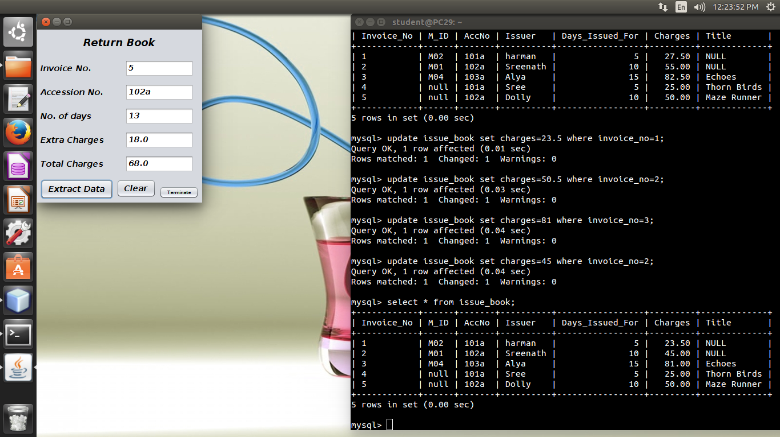

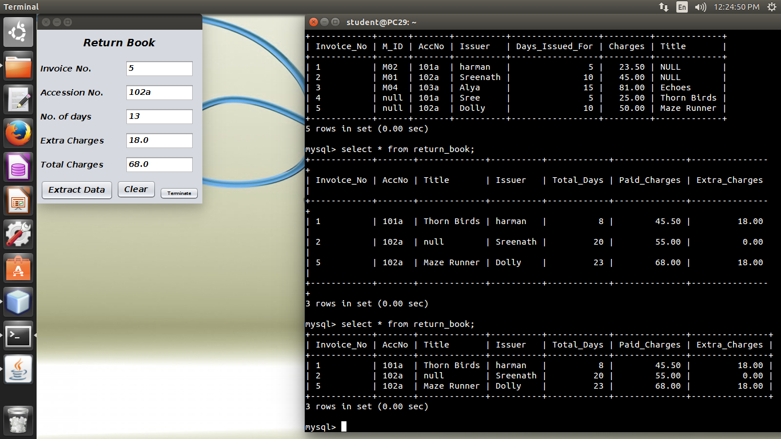

**Form 11 : Generate Bill**

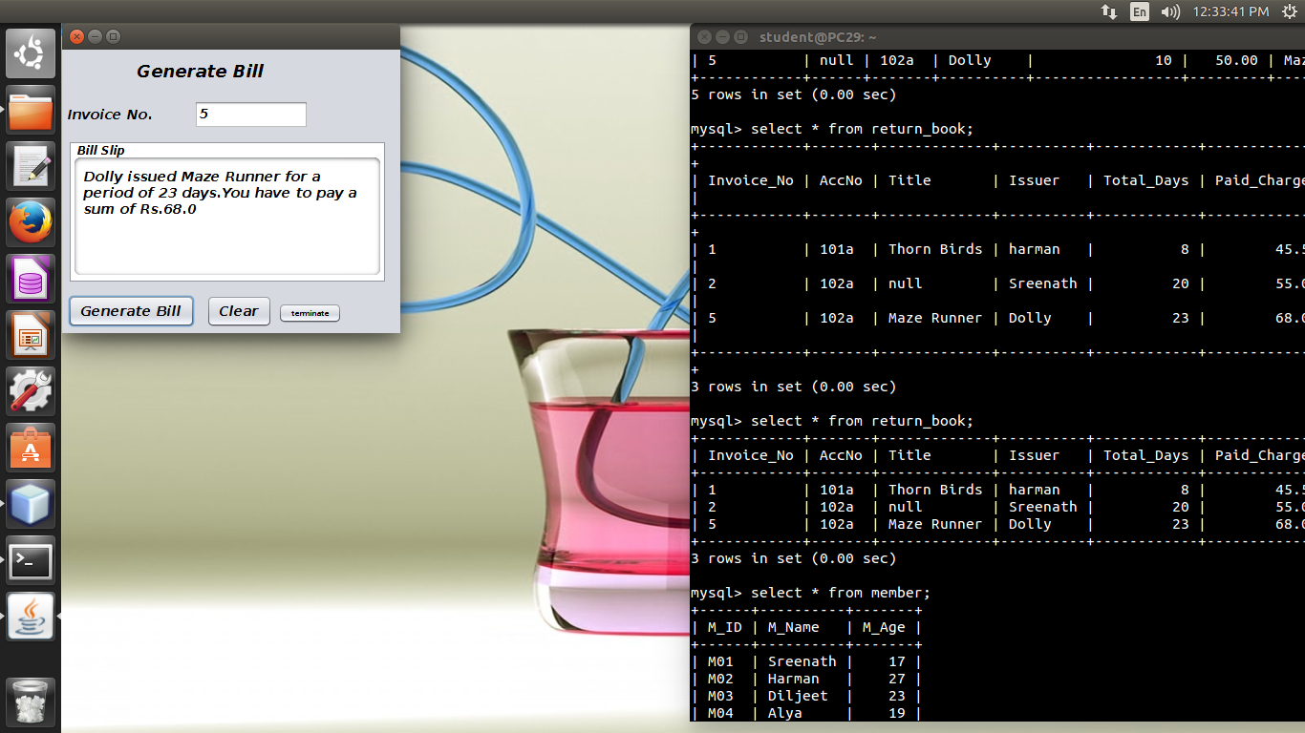

***CODING***

**Form 1 : Login Page**

**Login Button :**

import java.sql.DriverManager;

import com.mysql.jdbc.Connection;

import com.mysql.jdbc.Statement;

import java.sql.ResultSet;

import javax.swing.JOptionPane;

private void jButton1ActionPerformed(java.awt.event.ActionEvent evt) {

String id,pswrd;

id=jTextField1.getText();

pswrd=(jPasswordField1.getText());

try

{

Class.forName("java.sql.DriverManager");

Connection con = (Connection)

DriverManager.getConnection("jdbc:mysql://localhost/Library_Management_Software","root","");

Statement stmt= (Statement) con.createStatement();

String query="Select ID,Password from login where ID='"+id+"';";

ResultSet rs=stmt.executeQuery(query);

String Id="",pass="";

if(rs.next())

{

Id=rs.getString("ID");

pass=rs.getString("Password");

}

if((id.equals(Id))&&(pswrd.equals(pass)))

{

JOptionPane.showMessageDialog(this,"Safely logged in");

this.setVisible(false);

new Homepage().setVisible(true);

}

else if((id.equals(Id))&&(pswrd!=pass))

{

jPasswordField1.setText("");

}

else

{

JOptionPane.showMessageDialog(this, "Re-enter User id and password");

jTextField1.setText("");

jPasswordField1.setText("");

}

}

catch(Exception e)

{

JOptionPane.showMessageDialog(this, e.getMessage());

}

}

**Change Password Button :**

import java.sql.DriverManager;

import com.mysql.jdbc.Connection;

import com.mysql.jdbc.Statement;

import java.sql.ResultSet;

import javax.swing.JOptionPane;

private void jButton2ActionPerformed(java.awt.event.ActionEvent evt) {                                           
        String pass,pswrd,newpass1,newpass2;  
        String id=JOptionPane.showInputDialog(this,"Enter your user id");  
        try  
        {  
            Class.forName("java.sql.DriverManager");  
            Connection con = (Connection) DriverManager.getConnection("jdbc:mysql://localhost/Library_Management_Software","root","");  
            Statement stmt= (Statement) con.createStatement();  
            String query1="Select Password from login where ID='"+id+"';";  
            ResultSet rs=stmt.executeQuery(query1);  
            while(rs.next())  
            {  
                pass=rs.getString("Password");  
                pswrd=JOptionPane.showInputDialog(this,"Enter your current password");  
                if(pswrd.equals(pass))  
                {  
                   newpass1=JOptionPane.showInputDialog(this,"Enter new password");  
                   newpass2=JOptionPane.showInputDialog(this,"Confirm password");  
                   if(newpass1.equals(newpass2))  
                   {  
                       String query2="Update login set Password='"+newpass1+"' where

ID='"+id+"';";  
                       Statement stmt2= (Statement) con.createStatement();  
                       stmt2.executeUpdate(query2);  
                       JOptionPane.showMessageDialog(this, "Password updated

successfully");  
                   }  
                   else  
                   {  
                       JOptionPane.showMessageDialog(this,"Password doesn't match");  
                   }  
                }  
                else  
                {  
                    JOptionPane.showMessageDialog(this,"Password doesn't exist");  
                }  
            }  
              
        }  
        catch(Exception e)  
        {  
            JOptionPane.showMessageDialog(this, e.getMessage());  
        }  
    }

**Cancel Button :**

private void jButton3ActionPerformed(java.awt.event.ActionEvent evt) {

int a=JOptionPane.showConfirmDialog(this,"Do you want to

exit?","Quit",JOptionPane.YES_NO_OPTION);

if(a==0)

System.exit(0);

}

**Form 2 : Homepage**

**Books Menu**

* **Issue Book Menu Item :**

private void jMenuItem2ActionPerformed(java.awt.event.ActionEvent evt) {

this.setVisible(false);

new BookIssue().setVisible(true);

}

* **Return Book Menu Item :**

private void jMenuItem8ActionPerformed(java.awt.event.ActionEvent evt) {

this.setVisible(false);

new BookReturn().setVisible(true);

}

* **Insert Record Menu Item :**

private void jMenuItem3ActionPerformed(java.awt.event.ActionEvent evt) {

this.setVisible(false);

new BookinputRecord().setVisible(true);

}

* **Search and Update Record Menu Item :**

private void jMenuItem4ActionPerformed(java.awt.event.ActionEvent evt) {

this.setVisible(false);

new BookSearch().setVisible(true);

}

* **Retrieve records Menu Item :**

private void jMenuItem1ActionPerformed(java.awt.event.ActionEvent evt) {

this.setVisible(false);

new BooksRetrieve().setVisible(true);

}

**Member Menu**

* **Sign up Menu Item :**

private void jMenuItem5ActionPerformed(java.awt.event.ActionEvent evt) {

this.setVisible(false);

new MemberSignin().setVisible(true);

}

* **Search and Update Record Menu Item :**

private void jMenuItem6ActionPerformed(java.awt.event.ActionEvent evt) {

this.setVisible(false);

new MemberSearch().setVisible(true);

}

* **Retrieve records Menu Item :**

private void jMenuItem7ActionPerformed(java.awt.event.ActionEvent evt) {

this.setVisible(false);

new MembersRetrieve().setVisible(true);

}

**Generate Bill Menu**

private void jMenu11MouseClicked(java.awt.event.MouseEvent evt) {

this.setVisible(false);

new Generate_Bill().setVisible(true);

}

**Help Menu**

private void jMenu13MouseClicked(java.awt.event.MouseEvent evt) {

jTextArea1.setText("This program is a compatible Library Management Software"+

" which eases the procedure of handling the overall functions in a library. "+

"It includes insertion, searching , updatig and deleting of book records. "+

"It also includes member page to add members and their data altering forms. "+

"It can be used to generate bills readily just by using the use of invoice number and number of "+

"days it was returned after. The software has limitations as well which will be tackled in future updated versions.");

}

**Exit Menu**

private void jMenu14MouseClicked(java.awt.event.MouseEvent evt) {

int a=JOptionPane.showConfirmDialog(this,"You want to close the program");

if(a==0)

{

System.exit(0);

}

else

{

this.setVisible(true);

}

}

**Form 3 : Insert Book Records**

**Save Button :**

import java.sql.DriverManager;

import com.mysql.jdbc.Connection;

import com.mysql.jdbc.Statement;

import javax.swing.JOptionPane;

private void jButton1ActionPerformed(java.awt.event.ActionEvent evt) {

String accno,title,author,phouse;

accno=jTextField1.getText();

title=jTextField2.getText();

author=jTextField3.getText();

phouse=jTextField4.getText();

if((title.isEmpty())||(author.isEmpty())||(accno.isEmpty())||(phouse.isEmpty()))

{

JOptionPane.showMessageDialog(this,"Textfields not to be vacant");

}

else

{

try

{

Class.forName("java.sql.DriverManager");

Connection con=(Connection)

DriverManager.getConnection("jdbc:mysql://localhost/Library_Management_Software","root","");

Statement stmt= (Statement) con.createStatement();

String query="insert into book values('"+accno+"','"+title+"','"+author+"','"+phouse+"');";

stmt.executeUpdate(query);

JOptionPane.showMessageDialog(this,"Record inserted successfully");

jTextField1.setText("");

jTextField2.setText("");

jTextField3.setText("");

jTextField4.setText("");

}

catch(Exception e)

{

JOptionPane.showMessageDialog(this,e.getMessage());

}

}

}

**Terminate Button :**

private void jButton2ActionPerformed(java.awt.event.ActionEvent evt) {

this.setVisible(false);

new Homepage().setVisible(true);

}

**Form 4 : Manipulation of Book Records**

**Search Button :**

import java.sql.DriverManager;

import com.mysql.jdbc.Connection;

import com.mysql.jdbc.Statement;

import java.sql.ResultSet;

import javax.swing.JOptionPane;

private void jButton1ActionPerformed(java.awt.event.ActionEvent evt) {

String accno=jTextField1.getText();

try

{

Class.forName("java.sql.DriverManager");

Connection con=(Connection)

DriverManager.getConnection("jdbc:mysql://localhost/Library_Management_Software","root","");

Statement stmt= (Statement) con.createStatement();

String query="Select Title, Author, Publishing_House from book where AccNo='"+accno+"';";

ResultSet rs=stmt.executeQuery(query);

if(rs.next())

{

String title=rs.getString("Title");

String author=rs.getString("Author");

String phouse=rs.getString("Publishing_House");

jTextField2.setText(title);

jTextField3.setText(author);

jTextField4.setText(phouse);

jTextField2.setEditable(true);

jTextField3.setEditable(true);

jTextField4.setEditable(true);

jButton2.setEnabled(true);

jButton3.setEnabled(true);

}

else

{

JOptionPane.showMessageDialog(this, "No such Acc number exist");

}

}

catch(Exception e)

{

JOptionPane.showMessageDialog(this, e.getMessage());

}

}

**Update Button :**

import java.sql.DriverManager;

import com.mysql.jdbc.Connection;

import com.mysql.jdbc.Statement;

import java.sql.ResultSet;

import javax.swing.JOptionPane;

private void jButton2ActionPerformed(java.awt.event.ActionEvent evt) {

String accno,title,author,phouse;

accno=jTextField1.getText();

title=jTextField2.getText();

author=jTextField3.getText();

phouse=jTextField4.getText();

if((title.isEmpty())||(author.isEmpty())||(accno.isEmpty())||(phouse.isEmpty()))

{

JOptionPane.showMessageDialog(this,"Textfields not to be vacant");

}

else

{

try

{

Class.forName("java.sql.DriverManager");

Connection con=(Connection)

DriverManager.getConnection("jdbc:mysql://localhost/Library_Management_Software","root","");

Statement stmt= (Statement) con.createStatement();

String query="Update book set Title='"+title+"',Author='"+author+"',Publishing_House='"+phouse

+"' where AccNo ='"+accno+"';";

stmt.executeUpdate(query);

}

catch(Exception e)

{

JOptionPane.showMessageDialog(this, e.getMessage());

}

}

}

**Delete Button :**

import java.sql.DriverManager;

import com.mysql.jdbc.Connection;

import com.mysql.jdbc.Statement;

import java.sql.ResultSet;

import javax.swing.JOptionPane;

private void jButton3ActionPerformed(java.awt.event.ActionEvent evt) {

String accno=jTextField1.getText();

int a=JOptionPane.showConfirmDialog(this,"Do you want to delete the record","Comfirm",JOptionPane.YES_NO_OPTION);

if(a==0)

{

try

{

Class.forName("java.sql.DriverManager");

Connection con= (Connection)

DriverManager.getConnection("jdbc:mysql://localhost/Library_Management_Software","root","");

Statement stmt= (Statement) con.createStatement();

String query ="delete from book where AccNo='"+accno+"';";

stmt.executeUpdate(query);

}

catch(Exception e)

{

JOptionPane.showMessageDialog(this,e.getMessage());

}

}

}

**Clear Button :**

private void jButton4ActionPerformed(java.awt.event.ActionEvent evt) {

jTextField1.setText("");

jTextField2.setText("");

jTextField3.setText("");

jTextField4.setText("");

jTextField2.setEditable(false);

jTextField3.setEditable(false);

jTextField4.setEditable(false);

jButton2.setEnabled(false);

jButton3.setEnabled(false);

}

**Terminate Button :**

private void jButton5ActionPerformed(java.awt.event.ActionEvent evt) {

this.setVisible(false);

new Homepage().setVisible(true);

}

**Form 5 : Retrieve records depending on criteria**

**Retrieve Records Button :**

import java.sql.DriverManager;

import com.mysql.jdbc.Connection;

import com.mysql.jdbc.Statement;

import java.sql.ResultSet;

import javax.swing.JOptionPane;

import javax.swing.table.DefaultTableModel;

private void jButton1ActionPerformed(java.awt.event.ActionEvent evt) {

String fld="",oprt="",hint;

hint=jTextField1.getText();

if(jComboBox1.getSelectedIndex()==1)

{

fld="AccNo";

}

else if(jComboBox1.getSelectedIndex()==2)

{

fld="Title";

}

else if(jComboBox1.getSelectedIndex()==3)

{

fld="Author";

}

else if(jComboBox1.getSelectedIndex()==4)

{

fld="Publishing_House";

}

else

{

JOptionPane.showMessageDialog(this,"CHOOSE CORRECT OPTION");

}

if(jComboBox2.getSelectedIndex()==1)

{

oprt="=";

}

else if(jComboBox2.getSelectedIndex()==2)

{

oprt="<";

}

else if(jComboBox2.getSelectedIndex()==3)

{

oprt=">";

}

else if(jComboBox2.getSelectedIndex()==4)

{

oprt="<=";

}

else if(jComboBox2.getSelectedIndex()==5)

{

oprt=">=";

}

else if(jComboBox2.getSelectedIndex()==6)

{

oprt="!=";

}

else

{

JOptionPane.showMessageDialog(this,"CHOOSE CORRECT OPTION");

}

DefaultTableModel model = (DefaultTableModel)

jTable1.getModel();

try

{

Class.forName("java.sql.DriverManager");

Connection con = (Connection)

DriverManager.getConnection("jdbc:mysql://localhost/Library_Management_Software","root", "");

Statement stmt = (Statement) con.createStatement();

String query="Select * from book where "+ fld+""+oprt+"'"+hint+"';";

ResultSet rs= stmt.executeQuery(query);

while(rs.next())

{

String accno=rs.getString("AccNo");

String title=rs.getString("Title");

String author=rs.getString("Author");

String phouse=rs.getString("Publishing_House");

model.addRow(new Object[] {accno,title,author,phouse});

}

}

catch(Exception e)

{

JOptionPane.showMessageDialog(this, e.getMessage());

}

}

**Clear Button :**

import javax.swing.table.DefaultTableModel;

private void jButton2ActionPerformed(java.awt.event.ActionEvent evt) {

DefaultTableModel model = (DefaultTableModel) jTable1.getModel();

model.setRowCount(0);

jComboBox1.setSelectedIndex(0);

jComboBox2.setSelectedIndex(0);

jTextField1.setText("");

}

**Terminate Button:**

private void jButton3ActionPerformed(java.awt.event.ActionEvent evt) {

this.setVisible(false);

new Homepage().setVisible(true);

}

**Form 6 : Member Sign up**

**Save Button :**

import java.sql.DriverManager;

import com.mysql.jdbc.Connection;

import com.mysql.jdbc.Statement;

import javax.swing.JOptionPane;

private void jButton1ActionPerformed(java.awt.event.ActionEvent evt) {

String memid=jTextField1.getText();

String memname=jTextField2.getText();

int age=Integer.parseInt(jTextField3.getText());

if((memid.isEmpty())||(memname.isEmpty())||(age<12))

{

JOptionPane.showMessageDialog(this,"* Please fill all the fields with appropriate data *");

}

else

{

try

{

Class.forName("java.sql.DriverManager");

Connection con=(Connection) DriverManager.getConnection("jdbc:mysql://localhost/Library_Management_Software","root","");

Statement stmt= (Statement) con.createStatement();

String query="insert into member values('"+memid+"','"+memname+"',"+age+");";

stmt.executeUpdate(query);

JOptionPane.showMessageDialog(this,"HURRAY!\nNow you are a member of The Epoche's library.");

jTextField1.setText("");

jTextField2.setText("");

jTextField3.setText("");

}

catch(Exception e)

{

JOptionPane.showMessageDialog(this, e.getMessage());

}

}

}

**Terminate Button :**

private void jButton2ActionPerformed(java.awt.event.ActionEvent evt) {

this.setVisible(false);

new Homepage().setVisible(true); }

**Form 7 : Manipulation of Member Records**

**Search Button :**

import java.sql.DriverManager;

import com.mysql.jdbc.Connection;

import com.mysql.jdbc.Statement;

import java.sql.ResultSet;

import javax.swing.JOptionPane;

private void jButton1ActionPerformed(java.awt.event.ActionEvent evt) {

String memid=jTextField4.getText();

try

{

Class.forName("java.sql.DriverManager");

Connection con=(Connection)

DriverManager.getConnection("jdbc:mysql://localhost/Library_Management_Software","root","");

Statement stmt= (Statement) con.createStatement();

String query="Select M_Name, M_Age from member where M_ID='"+memid+"';";

ResultSet rs=stmt.executeQuery(query);

if(rs.next())

{

String memname=rs.getString("M_Name");

int age=rs.getInt("M_Age");

jTextField5.setText(memname);

jTextField6.setText(""+age);

jTextField5.setEditable(true);

jTextField6.setEditable(true);

jButton2.setEnabled(true);

jButton3.setEnabled(true);

}

else

{

JOptionPane.showMessageDialog(this, "No such member id exist");

}

}

catch(Exception e)

{

JOptionPane.showMessageDialog(this, e.getMessage());

}

}

**Update Button :**

import java.sql.DriverManager;

import com.mysql.jdbc.Connection;

import com.mysql.jdbc.Statement;

import java.sql.ResultSet;

import javax.swing.JOptionPane;

private void jButton2ActionPerformed(java.awt.event.ActionEvent evt) {

String memid,memname;

memid=jTextField4.getText();

memname=jTextField5.getText();

int age=Integer.parseInt(jTextField6.getText());

try

{

Class.forName("java.sql.DriverManager");

Connection con=(Connection)

DriverManager.getConnection("jdbc:mysql://localhost/Library_Management_Software","root","");

Statement stmt= (Statement) con.createStatement();

String query="Update member set M_Name='"+memname+"',M_Age="+age+" where M_ID='"+memid+"';";

stmt.executeUpdate(query);

}

catch(Exception e)

{

JOptionPane.showMessageDialog(this, e.getMessage());

}

}

**Delete Button :**

import java.sql.DriverManager;

import com.mysql.jdbc.Connection;

import com.mysql.jdbc.Statement;

import java.sql.ResultSet;

import javax.swing.JOptionPane;

private void jButton3ActionPerformed(java.awt.event.ActionEvent evt) {

String memid=jTextField4.getText();

int a=JOptionPane.showConfirmDialog(this,"Do you want to delete the record","Comfirm",JOptionPane.YES_NO_OPTION);

if(a==0)

{

try

{

Class.forName("java.sql.DriverManager");

Connection con= (Connection)

DriverManager.getConnection("jdbc:mysql://localhost/Library_Management_Software","root","");

Statement stmt= (Statement) con.createStatement();

String query ="delete from member where M_ID='"+memid+"';";

stmt.executeUpdate(query);

}

catch(Exception e)

{

JOptionPane.showMessageDialog(this,e.getMessage());

}

}

}

**Clear Button :**

private void jButton4ActionPerformed(java.awt.event.ActionEvent evt) {

jTextField4.setText("");

jTextField5.setText("");

jTextField6.setText("");

jTextField5.setEditable(false);

jTextField6.setEditable(false);

jButton2.setEnabled(false);

jButton3.setEnabled(false);

}

**Terminate Button :**

private void jButton5ActionPerformed(java.awt.event.ActionEvent evt) {

this.setVisible(false);

new Homepage().setVisible(true);

}

**Form 8 : Retrieve records depending on criteria**

**Retrieve Records Button :**

import java.sql.DriverManager;

import com.mysql.jdbc.Connection;

import com.mysql.jdbc.Statement;

import java.sql.ResultSet;

import javax.swing.JOptionPane;

import javax.swing.table.DefaultTableModel;

private void jButton1ActionPerformed(java.awt.event.ActionEvent evt) {

String fld="",oprt="",hint;

hint=jTextField1.getText();

if(jComboBox1.getSelectedIndex()==1)

{

fld="M_ID";

}

else if(jComboBox1.getSelectedIndex()==2)

{

fld="M_Name";

}

else if(jComboBox1.getSelectedIndex()==3)

{

fld="M_Age";

}

else

{

JOptionPane.showMessageDialog(this,"CHOOSE CORRECT OPTION");

}

if(jComboBox2.getSelectedIndex()==1)

{

oprt="=";

}

else if(jComboBox2.getSelectedIndex()==2)

{

oprt="<";

}

else if(jComboBox2.getSelectedIndex()==3)

{

oprt=">";

}

else if(jComboBox2.getSelectedIndex()==4)

{

oprt="<=";

}

else if(jComboBox2.getSelectedIndex()==5)

{

oprt=">=";

}

else if(jComboBox2.getSelectedIndex()==6)

{

oprt="!=";

}

else

{

JOptionPane.showMessageDialog(this,"CHOOSE CORRECT OPTION");

}

DefaultTableModel model = (DefaultTableModel)

jTable1.getModel();

try

{

Class.forName("java.sql.DriverManager");

Connection con = (Connection) DriverManager.getConnection("jdbc:mysql://localhost/Library_Management_Software","root", "");

Statement stmt = (Statement) con.createStatement();

String query="Select * from member where "+ fld+""+oprt+"'"+hint+"';";

ResultSet rs= stmt.executeQuery(query);

while(rs.next())

{

String memid=rs.getString("M_ID");

String name=rs.getString("M_Name");

int age=rs.getInt("M_Age");

model.addRow(new Object[] {memid,name,age});

}

}

catch(Exception e)

{

JOptionPane.showMessageDialog(this, e.getMessage());

}

}

**Clear Button :**

import javax.swing.table.DefaultTableModel;

private void jButton2ActionPerformed(java.awt.event.ActionEvent evt) {

DefaultTableModel model = (DefaultTableModel) jTable1.getModel();

model.setRowCount(0);

jComboBox1.setSelectedIndex(0);

jComboBox2.setSelectedIndex(0);

jTextField1.setText("");

}

**Terminate Button :**

private void jButton3ActionPerformed(java.awt.event.ActionEvent evt) {

this.setVisible(false);

new Homepage().setVisible(true);

}

**Form 9 : Issue Book**

**Save Button :**

import java.sql.DriverManager;

import com.mysql.jdbc.Connection;

import com.mysql.jdbc.Statement;

import javax.swing.JOptionPane;

private void jButton1ActionPerformed(java.awt.event.ActionEvent evt) {

String accno,title,invoice,issuer,memid=null;

int days=0;

Double discount=0.0,charge=0.0,total=0.0;

accno=jTextField1.getText();

title=jTextField2.getText();

invoice=jTextField7.getText();

issuer=jTextField8.getText();

if(jComboBox1.getSelectedIndex()==1)

{

charge=5.0;

}

else if(jComboBox1.getSelectedIndex()==2)

{

charge=7.5;

}

else if(jComboBox1.getSelectedIndex()==3)

{

charge=10.25;

}

if(jRadioButton1.isSelected())

{

days=5;

}

else if(jRadioButton2.isSelected())

{

days=10;

}

else if(jRadioButton3.isSelected())

{

days=15;

}

charge=charge*days;

if(jCheckBox1.isSelected()==true)

{

memid=jTextField3.getText();

discount=0.1*charge;

}

else

{

discount=0.0;

}

total=charge-discount;

try

{

Class.forName("java.sql.DriverManager");

Connection con=(Connection)

DriverManager.getConnection("jdbc:mysql://localhost/Library_Management_Software","root","");

Statement stmt= (Statement) con.createStatement();

String query="insert into issue_book values('"+invoice+"','"+memid+"','"+accno+"','"+

issuer+"',"+days+","+total+",'"+title+"');";

stmt.executeUpdate(query);

JOptionPane.showMessageDialog(this,"Book issued by "+issuer+" for "+days+" days.");

}

catch(Exception e)

{

JOptionPane.showMessageDialog(this,e.getMessage());

}

}

**Clear Button :**

private void jButton2ActionPerformed(java.awt.event.ActionEvent evt) {

jTextField1.setText("");

jTextField2.setText("");

jTextField3.setText("");

jTextField3.setEditable(false);

jTextField7.setText("");

jTextField8.setText("");

jCheckBox1.setSelected(false);

jRadioButton1.setSelected(true);

jComboBox1.setSelectedIndex(1);

}

**Terminate Button :**

private void jButton3ActionPerformed(java.awt.event.ActionEvent evt) {

this.setVisible(false);

new Homepage().setVisible(true);

}

**Form 10 : Return Book**

**Extract Data Button :**

import java.sql.DriverManager;

import com.mysql.jdbc.Connection;

import com.mysql.jdbc.Statement;

import java.sql.ResultSet;

import javax.swing.JOptionPane;

private void jButton1ActionPerformed(java.awt.event.ActionEvent evt) {

String accno,invoice,title,issuer;

int returndays,days;

Double charges,extra,paid;

invoice=jTextField1.getText();

returndays=Integer.parseInt(jTextField3.getText());

try

{

Class.forName("java.sql.DriverManager");

Connection con=(Connection)

DriverManager.getConnection("jdbc:mysql://localhost/Library_Management_Software","root","");

Statement stmt= (Statement) con.createStatement();

String query1="Select AccNo,Title,Issuer,Days_Issued_For,Charges from issue_book where Invoice_No='"+invoice+"';";

ResultSet rs=stmt.executeQuery(query1);

if(rs.next())

{

title=rs.getString("Title");

accno=rs.getString("AccNo");

issuer=rs.getString("Issuer");

days=rs.getInt("Days_Issued_For");

charges=rs.getDouble("Charges");

int extradays=returndays-days;

if(extradays>0)

{

extra=extradays*6.0;

}

else

{

extra=0.0;

}

paid=charges+extra;

jTextField2.setText(accno);

jTextField4.setText(""+extra);

jTextField5.setText(""+paid);

days=days+returndays;

String query2="insert into return_book values('"+invoice+"','"+accno+"','"

+title+"','"+issuer+"',"+days+","+paid+","+extra+");";

stmt.executeUpdate(query2);

}

else

{

JOptionPane.showMessageDialog(this, "No such Invoice number exists");

}

}

catch(Exception e)

{

JOptionPane.showMessageDialog(this, e.getMessage());

}

}

**Clear Button :**

private void jButton3ActionPerformed(java.awt.event.ActionEvent evt) {

jTextField1.setText("");

jTextField2.setText("");

jTextField3.setText("");

jTextField4.setText("");

jTextField5.setText("");

}

**Terminate Button :**

private void jButton2ActionPerformed(java.awt.event.ActionEvent evt) {

this.setVisible(false);

new Homepage().setVisible(true);

}

**Form 11 : Generate Bill**

**Generate Bill Button :**

import java.sql.DriverManager;

import com.mysql.jdbc.Connection;

import com.mysql.jdbc.Statement;

import java.sql.ResultSet;

import javax.swing.JOptionPane;

private void jButton1ActionPerformed(java.awt.event.ActionEvent evt) {

String invoice,title,issuer;

int days;

Double charges;

invoice=jTextField1.getText();

try

{

Class.forName("java.sql.DriverManager");

Connection con=(Connection)

DriverManager.getConnection("jdbc:mysql://localhost/Library_Management_Software","root","");

Statement stmt= (Statement) con.createStatement();

String query1="Select Title,Issuer,Paid_Charges,Total_Days from return_book where Invoice_No='"+invoice+"';";

ResultSet rs=stmt.executeQuery(query1);

if(rs.next())

{

title=rs.getString("Title");

issuer=rs.getString("Issuer");

charges=rs.getDouble("Paid_Charges");

days=rs.getInt("Total_Days");

jTextArea1.setText(issuer+" issued "+title+" for a period of "+days+

" days.You have to pay a sum of Rs."+charges);

}

else

{

JOptionPane.showMessageDialog(this, "No such invoice no. exist");

}

}

catch(Exception e)

{

JOptionPane.showMessageDialog(this, e.getMessage());

}

}

**Clear Button :**

private void jButton2ActionPerformed(java.awt.event.ActionEvent evt) {

jTextArea1.setText("");

jTextField1.setText("");

}

**Terminate Button :**

private void jButton3ActionPerformed(java.awt.event.ActionEvent evt) {

this.setVisible(false);

new Homepage().setVisible(true);

}

**Limitations :**

There are certain limitations in the software which will be tackled with in the updated versions.The limitations are mentioned below :

* The password required in the beginning ,if forgotton can not be changed
* Only one book can be issued at a time by an issuer.
* The program is not very secure.
* There is no backup – recover sysyem in this program
* The user needs to mention the dates of issue and return for calculation of charges.